Authors
(Management system and Organization)

Audit Report

Name 1, Name 2
Contributors
Name 1, Name 2
Editors
Name 1, Name 2
Layout
Tara Drev
Copyright
(C) 2019, VET21001
The VET21001 Consortium
Partner 1 X X
Partner 2 X X
Partner 3 X X
Partner 4 X X
Partner 5 X X
Partner 6 X X
Partner 7 X X

This project has been funded with support from the European Commission. This publication reflects the views only of the authors, and the Commission cannot be held responsible for any use which may be made of the information contained therein.
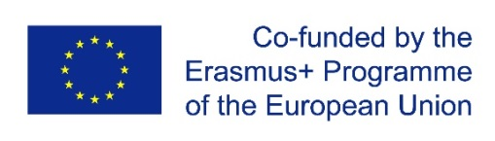
This work is licensed under a Creative Commons Attribution-ShareAlike 4.0 International
Table of Contents

1 Audit Report 4
1.1 Audit context 4
1.2 Audit plan 4
1.3 Audit sample 5
1.4 Audit summary 5
1.5 Audit results 5
1.6 Audit Conclusion 5
1.7 Audit findings 5
1.8 Audit findings 6
1.9 Audit Evidence 7
1.10 List of persons contacted / function 7

Audit Report

Audit context

Audit Type: | Criteria:
Audit Objectives:
Audit Scope:
Duration: | Auditor Team:
Audit Location:

Audit plan
Activity | Description (Processes, Criteria and Participants1) | Date and Time | Auditor | Location
Opening Meeting
Interviews, observation of activities and document analysis, by process
Preparation of the report
Closing Meeting
1 The audited organisation may add other staff elements to the various audit moments if desired. The auditor may request further interviews, with them or other employees, if they deem it necessary to achieve the audit objectives.

Audit sample

Audit summary

Audit results

Audit Conclusion

Audit findings

Audit findings
(SP: Strong Point; OI: Opportunity for Improvement; RI: Risk; NC: Nonconformity)

No. | Criteria | Type | Description
1
2
3
4
5
6
7
8
9
10
11
12
13
14
15
(Add rows as needed)

Audit Evidence

No. | Type¹ | Evidence
INT= Interview; OBS= Observation; DOC= Documented information

List of persons contacted / function
Name | Function / Organization role

About the VET21001 Project and this publication
The VET21001 project aims to develop a capacity building program, an accredited certification scheme and an implementation toolkit to motivate a wider EQAVET adoption. The VET21001 toolkit will use a standardized approach based on the recently published ISO 21001:2018, capitalizing on its already internationally consensually approved content and expecting that, by associating the ISO brand to EQAVET, all players in the market, including those of the standardization, accreditation and certification worlds, will become more curious about it, as well as willing to contribute to its dissemination and assuring its sustainability.

